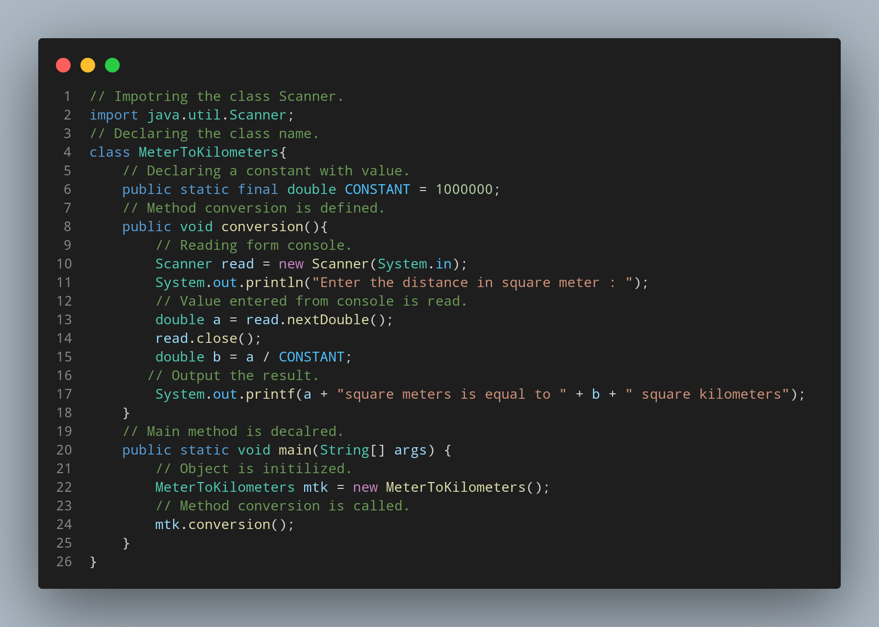

#Doc
java.util.Scanner class is imported.
MeterToKilometer is defined as class.
CONSTANT is declared as a constant with value of 1000000.
Method conversion is declared.
Code to read the data entered from console is written.
Code to print the required output is written.
Code to read and assign a variable to the entered data is written.
Variable b of double data type is declared.
Code to output the result is written.
Main method is declared.
Object is initialized.
conversion method is invoked.

